1 CHEETOS® Crunchy FLAMIN' HOT® Cheese Flavored Snacks 1.00

Ingredients:

Enriched Corn Meal (Corn Meal, Ferrous Sulfate, Niacin, Thiamin Mononitrate, Riboflavin, and Folic Acid),

Vegetable Oil (Corn, Canola, Soybean, and/or Sunflower Oil),

Flamin' Hot Seasoning (Lsee than 2% of the Following: Maltodextrin [Made From Corn], Salt, Sugar, Monosodium Glutamate, Yeast Extract, Citric Acid, Artificial Color [Red 40 Lake, Yellow 6 Lake, Yellow 6, Yellow 5], Partially Hydrogenated Soybean and Cottonseed Oil, Sunflower Oil, Cheddar Cheese [Milk, Cheese Cultures, Salt, Enzymes], Onion Powder, Whey, Whey Protein Concentrate, Garlic Powder, Corn Syrup Solids, Natural Flavor, Buttermilk, Sodium Diacetate, Sodium Caseinate, Lactic Acid, Disodium Inosinate, Disodium Guanylate, Skim Milk), and

Salt.

CONTAINS MILK INGREDIENTS

No Gluten, 0g Trans Fat

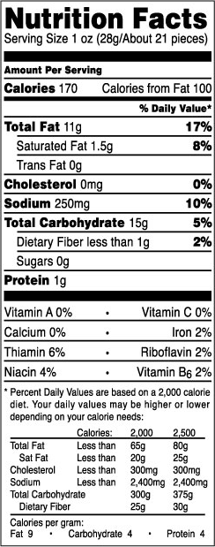

2 CHEETOS® Crunchy Cheese Flavored Snacks 1.00

Ingredients:

Enriched Corn Meal(Corn Meal, Ferrous Sulfate, Niacin, Thiamin Mononitrate, Riboflavin, and Folic Acid),

Vegetable Oil (Corn, Canola, Soybean, and/or Sunflower Oil),

Cheese Seasoning (Whey, and less than 2% of the Following: Cheddar Cheese [Milk, Cheese Cultures, Salt, Enzymes], Partially Hydrogenated Soybean Oil, Canola Oil, Maltodextrin [Made From Corn], Sour Cream [Cultured Cream, Skim Milk], Salt, Whey Protein Concentrate, Monosodium Glutamate, Natural and Artificial Flavors, Lactic Acid, Citric Acid, Artificial Color [Including Yellow 6]), and

Salt

CONTAINS MILK INGREDIENTS

No Gluten, 0g Trans Fat, Onion Free, Pig (Porcine) Free

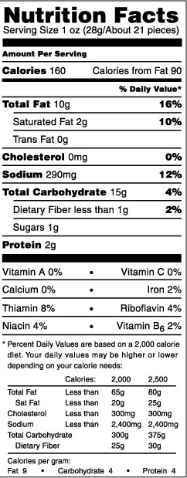

3 CHEETOS® Crunchy Cheddar Jalapeno Flavored Snacks 1.00

Ingredients:

Enriched Corn Meal (Corn Meal, Ferrous Sulfate, Niacin, Thiamin Mononitrate, Riboflavin, and Folic Acid),

Vegetable Oil (Corn, Canola, Soybean, and/or Sunflower Oil),

Cheddar Jalapeno Seasoning (Less than 2% of the Following: Cheddar Cheese (Milk, Cheese Cultures, Salt, Enzymes), Salt, Buttermilk, Whey, Romano Cheese [Part-Skim Cow's Milk, Cheese Cultures, Salt, Enzymes], Monosodium Glutamate, Whey Protein Concentrate, Onion Powder, Sugar, Partially Hydrogenated Soybean Oil, Corn Starch, Dextrose, Spices, Jalapeno Pepper, Garlic Powder, Artificial Color [Including Yellow 6, Yellow 5, Blue 1, and Red 40], Sunflower Oil, Citric Acid, Malic Acid, Lactic Acid, Disodium Inosinate, Disodium Guanylate, Skim Milk), and

Salt

CONTAINS MILK INGREDIENTS

No Gluten, 0g Trans Fat

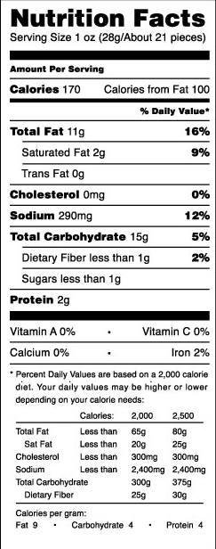

4 CHEETOS® Puffs Cheese Flavored Snacks 0.65

Ingredients:

Enriched Corn Meal (Corn Meal, Ferrous Sulfate, Niacin, Thiamin Mononitrate, Riboflavin, and Folic Acid),

Vegetable Oil (Corn, Canola, Soybean, and/or Sunflower Oil),

Cheese Seasoning (Whey, Cheddar Cheese [Milk, Cheese Cultures, Salt, Enzymes], and less than 2% of the following: Partially Hydrogenated Soybean Oil, Canola Oil, Maltodextrin [Made From Corn], Sour Cream [Cultured Cream, Skim Milk], Salt, Whey Protein Concentrate, Monosodium Glutamate, Natural and Artificial Flavors, Lactic Acid, Citric Acid, Artificial Color [Including Yellow 6]), and

Salt

CONTAINS MILK INGREDIENTS

No Gluten, 0g Trans Fat, Baked, Pig (Porcine) Free

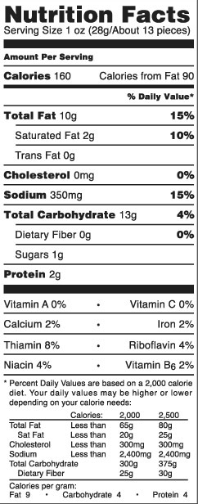

5 LAY'S® Barbecue Flavored Potato Chips 1.00

Ingredients:

Potatoes,

Vegetable Oil (Sunflower, Corn, and/or Canola Oil),

BBQ Seasoning (Sugar, Salt, Corn Sugar, Malted Barley Flour, Onion Powder, Yeast, Molasses, Spices, Garlic Powder, Natural Flavors, Paprika, Tomato Powder, Corn Starch, yeast Extract, and Paprika Extracts)

Good Source of Vitamin C, Kosher Triangle K, Lactose Free, MSG Free, Pig (Porcine) Free, Good Source of Potassium, Soy Free

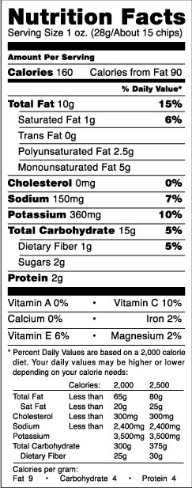

6 LAY'S® Classic Potato Chips 1.00

Ingredients:

Potatoes,

Vegetable Oil (Sunflower, Corn, and/or Canola Oil), and

Salt

No Preservatives

Gluten Free, 0g Trans Fat, Additive Free, Good Source of Vitamin C, Casein Free, Kosher OU, MSG Free, Onion Free, Pig (Porcine) Free, Soy Free

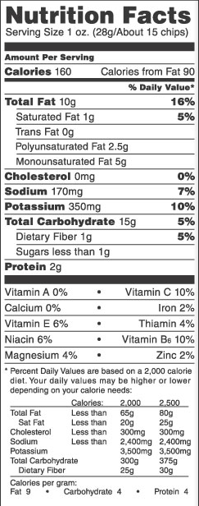

7 Aquafina 1.5

Ingredients:

Purified Water

8 Sierra Mist Natural 1.5

Ingredients: CARBONATED WATER, SUGAR, CITRIC ACID, NATURAL FLAVOR, POTASSIUM CITRATE

Serving size 8 fl oz (240 mL)  
Servings per 20 fl oz container: 2.5

|  | **8 fl oz** | **%DV\*** | **20 fl oz** | **%DV\*** |
| --- | --- | --- | --- | --- |
| Calories | 100 | - | 240 | - |
| Total Fat (g) | 0 | 0 | 0 | 0 |
| [Sodium (mg)](http://www.pepsicobeveragefacts.com/sodium.php) | 20 | 1 | 55 | 2 |
| Total Carbs (g) | 25 | 8 | 62 | 21 |
| Sugars (g) | 25 | - | 62 | - |
| Protein (g) | 0 | - | 0 | - |

Not a significant source of other nutrients.  
*Percent Daily Values (DV) are based on a 2,000 calorie diet.

Calorie and nutrient values are rounded as required by the Food & Drug Administration. This can produce irregularities among sizes. Product may not be available in all areas.

9 Pepsi 1.5

Ingredients:

CARBONATED WATER, HIGH FRUCTOSE CORN SYRUP, CARAMEL COLOR, SUGAR, PHOSPHORIC ACID, CAFFEINE, CITRIC ACID, NATURAL FLAVOR

Serving size 8 fl oz (240 mL)  
Servings per 20 fl oz container: 2.5

| [**Learn about serving sizes.**](javascript:;) | **8 fl oz** | **%DV\*** | **20 fl oz** | **%DV\*** |
| --- | --- | --- | --- | --- |
| Calories | 0 | - | 0 | - |
| Total Fat (g) | 0 | 0 | 0 | 0 |
| [Sodium (mg)](http://www.pepsicobeveragefacts.com/sodium.php) | 25 | 1 | 60 | 3 |
| Total Carbs (g) | 0 | 0 | 0 | 0 |
| Sugars (g) | 0 | - | 0 | - |
| Protein (g) | 0 | - | 0 | - |

Not a significant source of other nutrients.  
*Percent Daily Values (DV) are based on a 2,000 calorie diet.

Calorie and nutrient values are rounded as required by the Food & Drug Administration. This can produce irregularities among sizes. Product may not be available in all areas.

10 Mountain Dew 1.5

Ingredients: CARBONATED WATER, HIGH FRUCTOSE CORN SYRUP, CONCENTRATED ORANGE JUICE, CITRIC ACID, NATURAL FLAVORS, SODIUM BENZOATE (PRESERVES FRESHNESS), CAFFEINE, SODIUM CITRATE, ERYTHORBIC ACID (PRESERVES FRESHNESS), GUM ARABIC, CALCIUM DISODIUM EDTA (TO PROTECT FLAVOR), BROMINATED VEGETABLE OIL, YELLOW 5

Serving size 8 fl oz (240 mL)  
Servings per 20 fl oz container: 2.5

| [**Learn about serving sizes.**](javascript:;) | **8 fl oz** | **%DV\*** | **20 fl oz** | **%DV\*** |
| --- | --- | --- | --- | --- |
| Calories | 110 | - | 290 | - |
| Total Fat (g) | 0 | 0 | 0 | 0 |
| [Sodium (mg)](http://www.pepsicobeveragefacts.com/sodium.php) | 40 | 2 | 100 | 4 |
| Total Carbs (g) | 31 | 10 | 77 | 26 |
| Sugars (g) | 31 | - | 77 | - |
| Protein (g) | 0 | - | 0 | - |

Not a significant source of other nutrients.  
*Percent Daily Values (DV) are based on a 2,000 calorie diet.

Calorie and nutrient values are rounded as required by the Food & Drug Administration. This can produce irregularities among sizes. Product may not be available in all areas.

11 Diet Pepsi 1.5

Ingredients:

CARBONATED WATER, CARAMEL COLOR, ASPARTAME, PHOSPHORIC ACID, POTASSIUM BENZOATE (PRESERVES FRESHNESS), CAFFEINE, CITRIC ACID, NATURAL FLAVOR

Serving size 8 fl oz (240 mL)  
Servings per 20 fl oz container: 2.5

| [**Learn about serving sizes.**](javascript:;) | **8 fl oz** | **%DV\*** | **20 fl oz** | **%DV\*** |
| --- | --- | --- | --- | --- |
| Calories | 0 | - | 0 | - |
| Total Fat (g) | 0 | 0 | 0 | 0 |
| [Sodium (mg)](http://www.pepsicobeveragefacts.com/sodium.php) | 25 | 1 | 60 | 3 |
| Total Carbs (g) | 0 | 0 | 0 | 0 |
| Sugars (g) | 0 | - | 0 | - |
| Protein (g) | 0 | - | 0 | - |

Not a significant source of other nutrients.  
*Percent Daily Values (DV) are based on a 2,000 calorie diet.

Calorie and nutrient values are rounded as required by the Food & Drug Administration. This can produce irregularities among sizes. Product may not be available in all areas.

12 Pepsi Max 1.5

Ingredients:

CARBONATED WATER, CARAMEL COLOR, PHOSPHORIC ACID, ASPARTAME, POTASSIUM BENZOATE (PRESERVES FRESHNESS), CAFFEINE, NATURAL FLAVOR, ACESULFAME POTASSIUM, CITRIC ACID, CALCIUM DISODIUM EDTA (TO PROTECT FLAVOR), PANAX GINSENG EXTRACT

Serving size 8 fl oz (240 mL)  
Servings per 20 fl oz container: 2.5

| [**Learn about serving sizes.**](javascript:;) | **8 fl oz** | **%DV\*** | **20 fl oz** | **%DV\*** |
| --- | --- | --- | --- | --- |
| Calories | 0 | - | 0 | - |
| Total Fat (g) | 0 | 0 | 0 | 0 |
| [Sodium (mg)](http://www.pepsicobeveragefacts.com/sodium.php) | 25 | 1 | 65 | 3 |
| Total Carbs (g) | 0 | 0 | 0 | 0 |
| Sugars (g) | 0 | - | 0 | - |
| Protein (g) | 0 | - | - | - |

Not a significant source of other nutrients.  
*Percent Daily Values (DV) are based on a 2,000 calorie diet.

Calorie and nutrient values are rounded as required by the Food & Drug Administration. This can produce irregularities among sizes. Product may not be available in all areas.

13 AMP Energy ??

Ingredients:

CARBONATED WATER, HIGH FRUCTOSE CORN SYRUP, CITRIC ACID, ORANGE JUICE CONCENTRATE, NATURAL FLAVOR, GUARANA SEED EXTRACT, SODIUM BENZOATE (PRESERVES FRESHNESS), SODIUM HEXAMETAPHOSPHATE (TO PROTECT FLAVOR), CAFFEINE, MALTODEXTRIN, GUM ARABIC, ASCORBIC ACID (TO PROTECT FLAVOR), TAURINE, PANAX GINSENG ROOT EXTRACT, CALCIUM DISODIUM EDTA (TO PROTECT FLAVOR), BROMINATED VEGETABLE OIL, NIACINAMIDE, YELLOW 5, CALCIUM PANTOTHENATE, RIBOFLAVIN, PYRIDOXINE HYDROCHLORIDE (VITAMIN B6), BLUE 1, CYANOCOBALAMIN (VITAMIN B12)

Each 8 fl oz (240ml) serving contains:

Guarana Extract 150mg, Caffeine 71mg, Maltodextrin 55mg, Taurine 10mg, Panax Ginseng Extract 10mg.

Not recommended for children, pregnant women or people sensitive to caffeine.

Serving size 8 fl oz (240 mL)  
Servings per 16 fl oz container: 2

| [**Learn about serving sizes.**](javascript:;) | **8 fl oz** | **%DV\*** | **16 fl oz** | **%DV\*** |
| --- | --- | --- | --- | --- |
| Calories | 110 | - | 220 | - |
| Total Fat (g) | 0 | 0 | 0 | 0 |
| [Sodium (mg)](http://www.pepsicobeveragefacts.com/sodium.php) | 65 | 3 | 135 | 6 |
| Total Carbs (g) | 29 | 10 | 58 | 20 |
| Sugars (g) | 29 | - | 58 | - |
| Protein (g) | 0 | - | 0 | - |
| Riboflavin | - | 20 | - | 40 |
| Niacin | - | 10 | - | 20 |
| Vitamin B6 | - | 10 | - | 20 |
| Vitamin B12 | - | 10 | - | 20 |
| Pantothenic Acid | - | 10 | - | 20 |

Not a significant source of other nutrients.  
*Percent Daily Values (DV) are based on a 2,000 calorie diet.

Calorie and nutrient values are rounded as required by the Food & Drug Administration. This can produce irregularities among sizes. Product may not be available in all areas.

14 Lipton Brisk Lemon Iced Tea 1.5

Ingredients:

WATER, HIGH FRUCTOSE CORN SYRUP, CITRIC ACID, INSTANT TEA, SODIUM HEXAMETAPHOSPHATE (TO PROTECT FLAVOR), NATURAL FLAVORS, PHOSPHORIC ACID, SODIUM BENZOATE AND POTASSIUM SORBATE (PRESERVE FRESHNESS), CARAMEL COLOR, CALCIUM DISODIUM EDTA (TO PROTECT FLAVOR), RED 40

Serving size 8 fl oz (240 mL)  
Servings per 20 fl oz container: 2.5

| [**Learn about serving sizes.**](javascript:;) | **8 fl oz** | **%DV\*** | **20 fl oz** | **%DV\*** |
| --- | --- | --- | --- | --- |
| Calories | 80 | - | 210 | - |
| Total Fat (g) | 0 | 0 | 0 | 0 |
| [Sodium (mg)](http://www.pepsicobeveragefacts.com/sodium.php) | 65 | 3 | 170 | 7 |
| Total Carbs (g) | 22 | 7 | 55 | 18 |
| Sugars (g) | 22 | - | 55 | - |
| Protein (g) | 0 | - | 0 | - |

Not a significant source of other nutrients.  
*Percent Daily Values (DV) are based on a 2,000 calorie diet.

Calorie and nutrient values are rounded as required by the Food & Drug Administration. This can produce irregularities among sizes. Product may not be available in all areas.

15 Orange Dream Bar 1.00

Ingredients:

Reduced Fat Ice Cream: Milk Fat and Nonfat Milk, Buttermilk, Whey, Sugar, Corn Syrup, Mono & Diglycerides, Carob Bean Gum, Guar Gum, Polysorbate 80, Carrageenan, Natural Flavor, Artificial Flavor, Vitamin A Palmitate.

This product, when extremely cold, may stick to warm lips or tongue. Allow to warm slightly before eating.

ALLERGEN INFORMATION: Contains milk.

Nutrition Facts

Serving Size 1 Bar (53g)

Amount Per Serving

|  |  |
| --- | --- |
| Calories 70 | Calories from Fat 10 |

% Daily Values**

|  |  |
| --- | --- |
| Total Fat 1g | 2% |
| Saturated Fat 0.5g | 4% |

|  |  |
| --- | --- |
| Trans Fat 0g |  |
| Cholesterol Less than 5mg | 2% |

|  |  |
| --- | --- |
| Sodium 25mg | 1% |
| Potassium 60mg | 2% |

|  |  |
| --- | --- |
| Total Carbohydrate 15g | 5% |
| Dietary Fiber 0g | 0% |

|  |  |
| --- | --- |
| Sugars 12g |  |
| Protein Less than 1g | 2% |

|  |  |
| --- | --- |
| Vitamin A | * |

|  |  |
| --- | --- |
| • Vitamin C | * |

|  |  |
| --- | --- |
| Calcium | 4% |

|  |  |
| --- | --- |
| • Iron | * |

|  |  |
| --- | --- |
| Riboflavin | 4% |

|  |  |
| --- | --- |
| • Phosphorus | 4% |

*Contains less than 2% of these values   
**Percent Daily Values are based on a 2,000 calorie diet. Your daily values may be higher or lower depending on your calorie needs:

|  |  |  |  |
| --- | --- | --- | --- |
|  | Calories: | 2,000 | 2,500 |
| Total Fat | Less than | 65g | 80g |
| Saturated Fat | Less than | 20g | 25g |
| Cholesterol | Less than | 300mg | 300mg |
| Sodium | Less than | 2,400mg | 2,400mg |
| Potassium |  | 3,500mg | 3,500mg |
| Total Carbohydrate |  | 300g | 375g |
| Dietary Fiber |  | 25g | 30g |
| Protein |  | 50g | 65g |

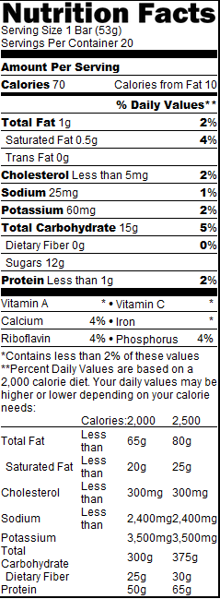

16 Cookies 'n Cream Ice Cream Bar 1.25

INGREDIENTS: Ice Cream: Milk Fat and Nonfat Milk, Buttermilk, Sugar, Whey, Cookie Pieces {Enriched Wheat Flour (Flour, Niacin, Reduced Iron, Thiamine Mononitrate, Riboflavin, Folic Acid), Sugar, Vegetable Shortening (Contains One or More of the Following: Canola Oil, Corn Oil, Palm Oil and/or Soybean Oil), Dextrose, Cocoa Processed with Alkali, High Fructose Corn Syrup, Contains 2% or Less of the Following: Corn Starch, Chocolate Liquor, Corn Syrup, Leavening (Sodium Bicarbonate, Monocalcium Phosphate, Ammonium Bicarbonate), Salt, Natural and Artificial Flavor, Yellow Corn Flour, Caramel Color, Soy Lecithin}, Corn Syrup, Mono & Diglycerides, Guar Gum, Cellulose Gum, Natural and Artificial Vanilla Flavor, Carrageenan, Polysorbate 80.

ALLERGEN INFORMATION: Contains milk, soy and wheat.

Serving Size 1 bar (70g)

Amount Per Serving

|  |  |
| --- | --- |
| Calories 220 | Calories from Fat 120 |

% Daily Values**

|  |  |
| --- | --- |
| Total Fat 13g | 21% |
| Saturated Fat 4.5g | 22% |

|  |  |
| --- | --- |
| Trans Fat 0.5g |  |
| Cholesterol 20mg | 6% |

|  |  |
| --- | --- |
| Sodium 115mg | 5% |
| Potassium 130mg | 4% |

|  |  |
| --- | --- |
| Total Carbohydrate 24g | 8% |
| Dietary Fiber Less than 1g | 3% |

|  |  |
| --- | --- |
| Sugars 15g |  |
| Protein 3g | 5% |

|  |  |
| --- | --- |
| Vitamin A | 4% |

|  |  |
| --- | --- |
| • Vitamin C | * |

|  |  |
| --- | --- |
| Calcium | 6% |

|  |  |
| --- | --- |
| • Iron | 2% |

|  |  |
| --- | --- |
| Riboflavin | 6% |

|  |  |
| --- | --- |
| • Vitamin B12 | 2% |

|  |  |
| --- | --- |
| Phosphorus | 4% |

*Contains less than 2% of these values   
**Percent Daily Values are based on a 2,000 calorie diet. Your daily values may be higher or lower depending on your calorie needs:

|  |  |  |  |
| --- | --- | --- | --- |
|  | Calories: | 2,000 | 2,500 |
| Total Fat | Less than | 65g | 80g |
| Saturated Fat | Less than | 20g | 25g |
| Cholesterol | Less than | 300mg | 300mg |
| Sodium | Less than | 2,400mg | 2,400mg |
| Potassium |  | 3,500mg | 3,500mg |
| Total Carbohydrate |  | 300g | 375g |
| Dietary Fiber |  | 25g | 30g |
| Protein |  | 50g | 65g |

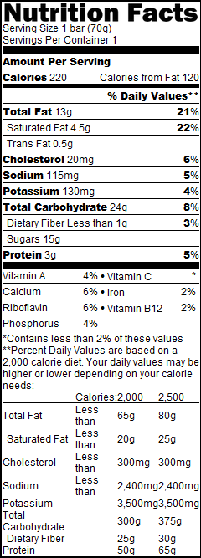

17 Vanilla Ice Cream Sandwiches 1.00

INGREDIENTS: Ice Cream: Milk Fat and Nonfat Milk, Corn Syrup, Buttermilk, Whey, Sugar, Maltodextrin, High Fructose Corn Syrup, Contains less than ½% of Propylene Glycol Monoesters, Mono & Diglycerides, Guar Gum, Carob Bean Gum, Cellulose Gel, Cellulose Gum, Carrageenan, Natural Flavor, Annatto (for Color), Vitamin A Palmitate. Wafers: Wheat Flour, Sugar, Cocoa, Soybean and Palm Oil, Dextrose, Caramel Color, Corn Syrup, Baking Soda, High Fructose Corn Syrup, Yellow Corn Flour, Food Starch Modified, Salt, Soy Lecithin, Chocolate Flavor.

ALLERGEN INFORMATION: Contains milk, soy and wheat

Serving Size 1 sandwich (57g)

Amount Per Serving

|  |  |
| --- | --- |
| Calories 140 | Calories from Fat 30 |

% Daily Values**

|  |  |
| --- | --- |
| Total Fat 3g | 5% |
| Saturated Fat 1.5g | 8% |

|  |  |
| --- | --- |
| Trans Fat 0g |  |
| Cholesterol 5mg | 2% |

|  |  |
| --- | --- |
| Sodium 170mg | 7% |
| Potassium 70mg | 2% |

|  |  |
| --- | --- |
| Total Carbohydrate 25g | 8% |
| Dietary Fiber Less than 1g | 4% |

|  |  |
| --- | --- |
| Sugars 12g |  |
| Protein 3g | 6% |

|  |  |
| --- | --- |
| Vitamin A | 4% |

|  |  |
| --- | --- |
| • Vitamin C | * |

|  |  |
| --- | --- |
| Calcium | 6% |

|  |  |
| --- | --- |
| • Iron | 4% |

|  |  |
| --- | --- |
| Riboflavin | 4% |

|  |  |
| --- | --- |
| • Vitamin B12 | 2% |

|  |  |
| --- | --- |
| Phosphorus | 4% |

*Contains less than 2% of these values   
**Percent Daily Values are based on a 2,000 calorie diet. Your daily values may be higher or lower depending on your calorie needs:

|  |  |  |  |
| --- | --- | --- | --- |
|  | Calories: | 2,000 | 2,500 |
| Total Fat | Less than | 65g | 80g |
| Saturated Fat | Less than | 20g | 25g |
| Cholesterol | Less than | 300mg | 300mg |
| Sodium | Less than | 2,400mg | 2,400mg |
| Potassium |  | 3,500mg | 3,500mg |
| Total Carbohydrate |  | 300g | 375g |
| Dietary Fiber |  | 25g | 30g |
| Protein |  | 50g | 65g |

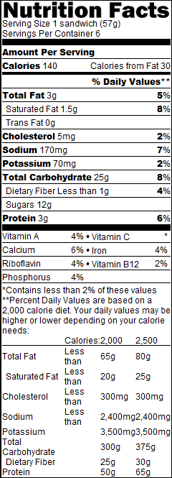

18 Chocolate Ice Cream Sundae Crunch® Bar 1.25

INGREDIENTS: ICE CREAM: Milk, Cream, Sugar, Corn Syrup, Whey Protein Concentrate, Whey, Mono & Diglycerides, Vanilla Extract, Guar Gum, Calcium Sulfate, Carob Bean Gum, Polysorbate 65, Carrageenan, Annatto (For Color). FLAVORED CENTER: Water, Sugar, Nonfat Milk, Corn Syrup, Whey, Cocoa (Partially Processed with Alkali), Dextrose, Caramel Color, Salt, Carob Bean Gum, Guar Gum, Carrageenan, Vanillin, Red 40, Blue 1, Sulfur Dioxide. CAKE CRUNCH: Enriched Wheat Flour (Bleached Flour, Niacin, Reduced Iron, Thiamin Mononitrate, Riboflavin, Folic Acid), Sugar, Vegetable Shortening (Partially Hydrogenated Soybean and Cottonseed Oils), Caramel Color, Cocoa Powder (Processed with Alkali), Corn Syrup, Salt, Artificial Vanilla, Sodium Bicarbonate, Soy Lecithin. DIP COATING: Soybean Oil, Partially Hydrogenated Coconut Oil, Sugar, Cocoa (Processed with Alkali), Soy Lecithin, Vanillin.

ALLERGEN INFORMATION: Contains milk and wheat

Serving Size 1 Bar (62g)

Amount Per Serving

|  |  |
| --- | --- |
| Calories 170 | Calories from Fat 80 |

% Daily Values**

|  |  |
| --- | --- |
| Total Fat 9g | 14% |
| Saturated Fat 3.5g | 18% |

|  |  |
| --- | --- |
| Trans Fat 0g |  |
| Cholesterol 15mg | 5% |

|  |  |
| --- | --- |
| Sodium Less than 85mg | 4% |
| Potassium 60mg | 2% |

|  |  |
| --- | --- |
| Total Carbohydrate 21g | 7% |
| Dietary Fiber 0g | 0% |

|  |  |
| --- | --- |
| Sugars 13g |  |
| Protein 2g | 4% |

|  |  |
| --- | --- |
| Vitamin A | 0% |

|  |  |
| --- | --- |
| • Vitamin C | 0% |

|  |  |
| --- | --- |
| Calcium | 0% |

|  |  |
| --- | --- |
| • Iron | 0% |

|  |  |
| --- | --- |
| Phosphorus | 4% |

*Contains less than 2% of these values   
**Percent Daily Values are based on a 2,000 calorie diet. Your daily values may be higher or lower depending on your calorie needs:

|  |  |  |  |
| --- | --- | --- | --- |
|  | Calories: | 2,000 | 2,500 |
| Total Fat | Less than | 65g | 80g |
| Saturated Fat | Less than | 20g | 25g |
| Cholesterol | Less than | 300mg | 300mg |
| Sodium | Less than | 2,400mg | 2,400mg |
| Potassium |  | 3,500mg | 3,500mg |
| Total Carbohydrate |  | 300g | 375g |
| Dietary Fiber |  | 25g | 30g |
| Protein |  | 50g | 65g |

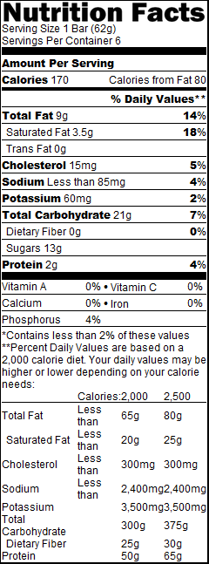

19 Wrigley's Spearmint® 0.75

INGREDIENTS:

SUGAR, GUM BASE, DEXTROSE, CORN SYRUP; LESS THAN 2% OF: NATURAL AND ARTIFICIAL FLAVORS, GLYEROL, SOY LECITHIN, ASPARTAME, ACESULFAME K, COLORS (YELLOW 5 LAKE, BLUE 1 LAKE), BHT (TO MAINTAIN FRESHNESS). PHENYLKETONURICS: CONTAINS PHENYLALANINE.

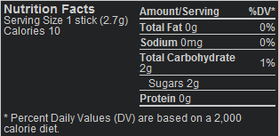

**Nutrition Facts**  
Serving Size 1 stick (2.7g)  
Calories 10

|  |  |
| --- | --- |
| **Amount/Serving** | **%DV\*** |
| **Total Fat** 0g | 0% |
| **Sodium** 0mg | 0% |
| **Total Carbohydrate**2g | 1% |
| Sugars 2g |  |
| **Protein** 0g |  |

* Percent Daily Values (DV) are based on a 2,000 calorie diet.

20 Winterfresh® 0.75

INGREDIENTS:

SUGAR, GUM BASE, DEXTROSE, CORN SYRUP, NATURAL AND ARTIFICIAL FLAVORS; LESS THAN 2% OF: GLYCEROL, ASPARTAME, SOY LECITHIN, ACESULFAME K, COLOR (BLUE 1 LAKE), BHT (TO MAINTAIN FRESHNESS). PHENYLKETONURICS: CONTAINS PHENYLALANINE.

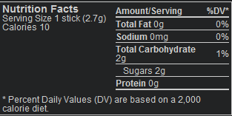

**Nutrition Facts**  
Serving Size 1 stick (2.7g)  
Calories 10

|  |  |
| --- | --- |
| **Amount/Serving** | **%DV\*** |
| **Total Fat** 0g | 0% |
| **Sodium** 0mg | 0% |
| **Total Carbohydrate**2g | 1% |
| Sugars 2g |  |
| **Protein** 0g |  |

* Percent Daily Values (DV) are based on a 2,000 calorie diet.